

**BXXIX-2254/1, KANGANWAL ROAD, P.O JUGIANA, LUDHIANA, PUNJAB – 141120, INDIA**

**MACHINING LINE BALANCING OF CRANCKSHAFT ( JCB 4.4L CYL)**

**INTRODUCTION**

A production line is said to be in balance when every worker's task takes the same amount of time. Line balancing is a manufacturing-engineering function in which whole collection of production-line tasks are divided into equal portions. Well-balanced lines avoid labor idealness and improve productivity.

The objective of LINE BALANCING is to reduce waste of time and highly responsive to the customer demand while producing quality product in the most efficient and economical manner.

**Advantages of LINE BALANCING**

* Uniform rate of production
* Less work in process
* Effective use of facilities
* Easy production control
* Increased production line efficiency
* Promotes one piece flow
* Reduces variation
* Minimizes Idle time

**TYPE OF PRODUCTION LINE**

* FLOW SHOP (IS IN USE)
* JOB SHOP
* PROJECT SHOP

**ADVANTAGES OF FLOW –LINE PRODUCTION**

1. Smooth flow of material from one work station to next.
2. Since work fed from one station to next small in process inventories.
3. Total production time/unit short.
4. Reduced material handling. Little skill required by operator hence training simple, short and inexpensive.
5. Simple production planning and control system.
6. Less space occupied by work in taint for temporary storage.

**DISADVANTAGES OF FLOW-LINE PRODUCTION**

1. A breakdown of machine may lead to a complete stoppage of following machine hence maintenance is a challenging job.
2. Inflexible with regard to changes in product design.
3. Pace determined by bottleneck machine. Line balancing is thus a major problem in design.
4. Supervision is general rather than specialized as the supervision of a line is looking after diver’s machines on a line.
5. Generally high investment is required owing to the specialized nature of the machines and their possible duplication in the line.

**GROUP OF TASK INTO WORK STATION**

* The feasible range of cycle times
* Line balancing methods
* Choice best design

**DATA COLLECTION**

Data are collected and recorded from the actual production in the happy forgings on the shift basics.

**CRANCKSHAFT JCB 4.4L**

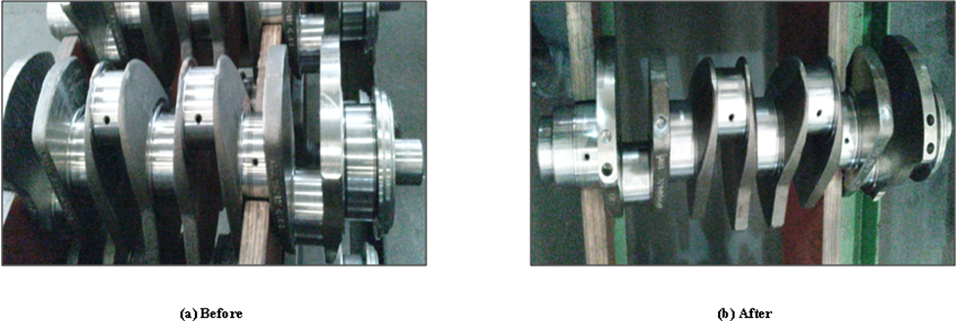

**Material Used**

SAE 1548

Hardness (229-269 BHN)

**Component Layout**

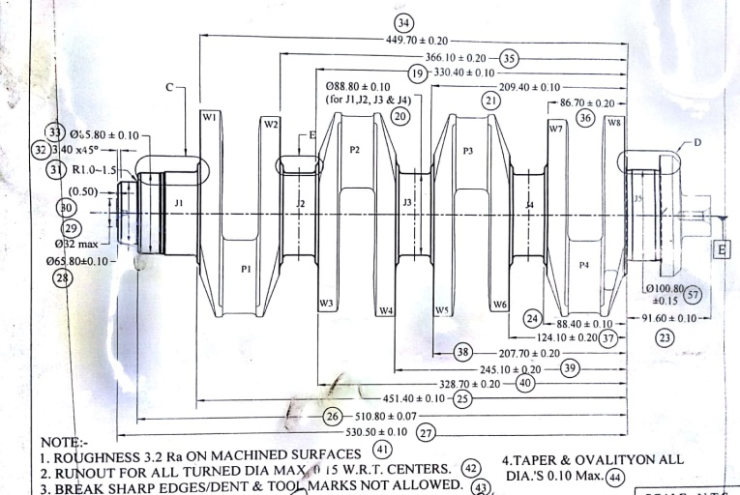 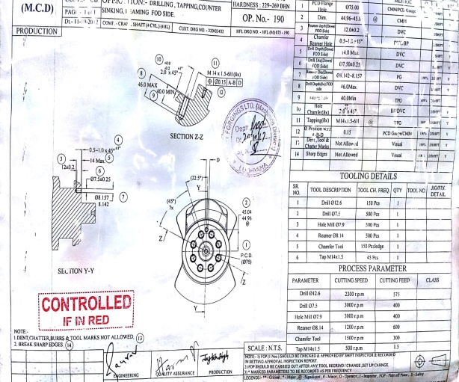

**General Layout PCD and Gear Hand Side Layout**

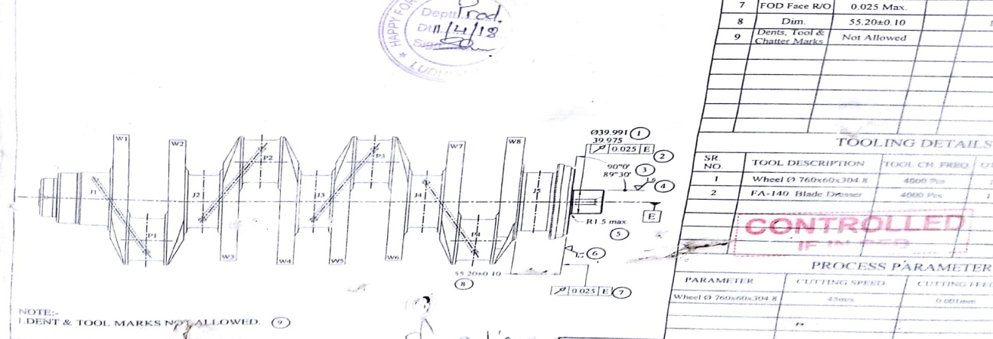

**Oil hole layout**

**MACHINING PROCESSES**

Facing and centering

This facing and centering helps in proper clamping of the crankshaft on the machines for the further operations. **BFW PRIMA55** machine is used for facing and centering of crankshaft jcb4.4 cylinder. The **cycle time** of machine is **540 seconds**.

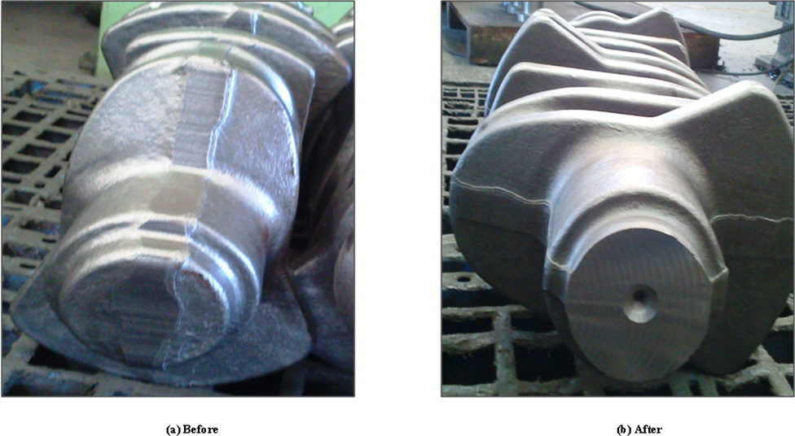

Rough and finish turning of all journals

The next operation is to do rough and finish turning of the gear end and all journals **J1,J2,J3,J4 and J5** of the crankshafts. **BFW PL-500EX TWIN** machine is used for rough and finish turning. The cycle time of this process is **508 seconds.**

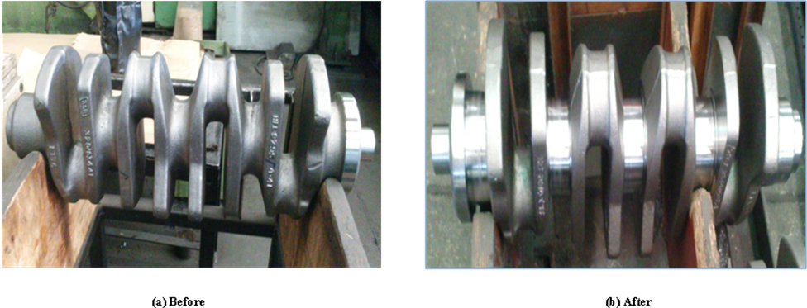

Finish turning of flange, face, pilot and web radius

Next operation is to do finish turning of flange diameter and width, face of dia, pilot and web radius. **BFW PL-500S** machine is used for this process. The cycle time for this process is **467 seconds**.

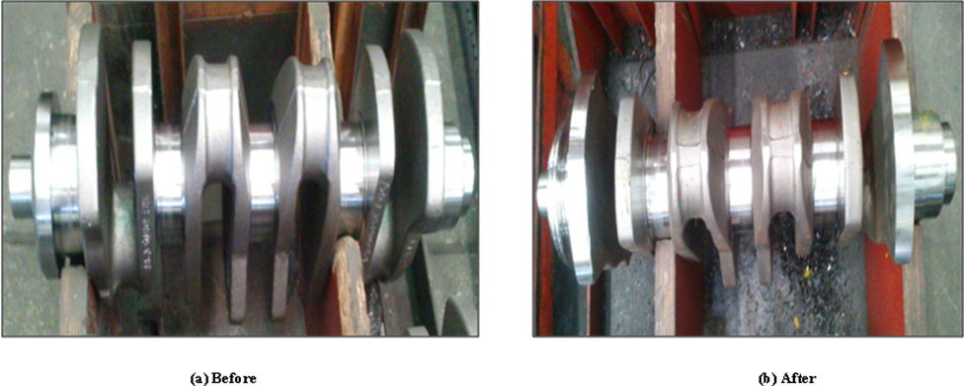

All pin rough and finish milling

In pin milling 90 inserts are used at one time. 72 inserts are used as radius and collar inserts and 18 inserts are use as center inserts. These inserts work together as multiple cutting teeth tool for milling operation of the crankshaft. **Heller** is used for pin milling. The cycle time for this process is **615 seconds**.

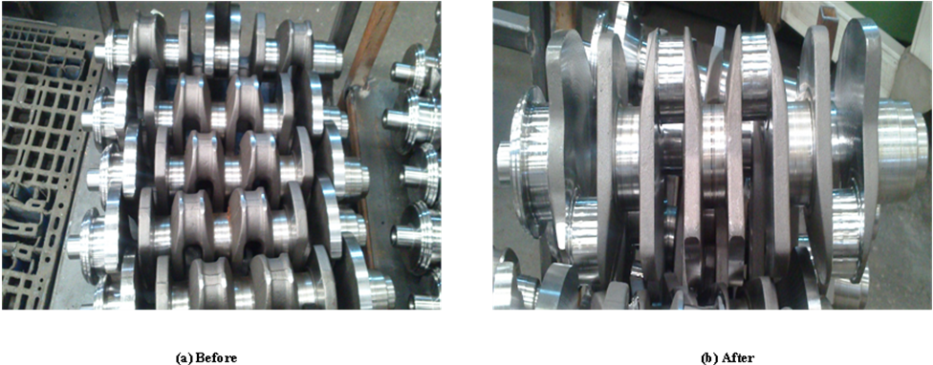

Oil hole drilling

Next operation is to do angular oil hole drilling, chamfering on all pins. Oil hole operation is one of the major critical from quality point of view. Each crankshaft model has its separate depth of oil hole. **BFW PDM 300/1000** angular oil hole vmc machine is used for this process. The cycle time for this process is **391 seconds**.

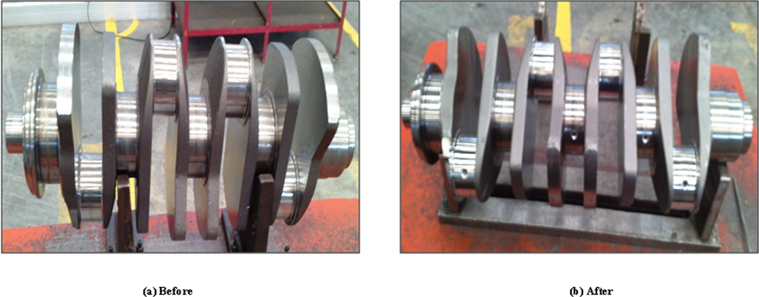

Induction hardening

After the completion of the milling operation the next operation is to do induction hardening of the crankshaft. This hardening operation is done enhance the properties of the crankshaft’s material. It increases the machineability and hardness of the crankshaft. The cycle time for this process is **585 seconds**. The heating time is 15 second per pin and quenching time is 12 second per pin.

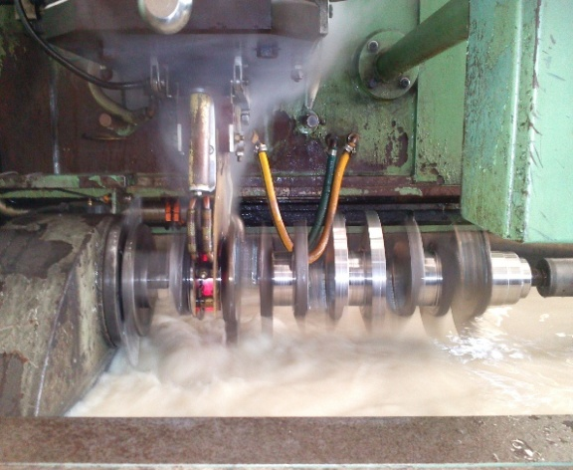 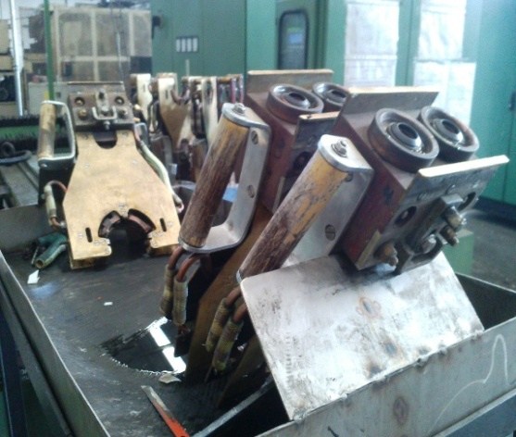

Tempering

After the hardening process internal stresses get developed inside the material which decreases the machineablity of the material. To remove these internal stresses tempering is done on the crankshaft by reheating the crankshaft on a predetermined temperature. The cycle time for this process is **180 seconds**.

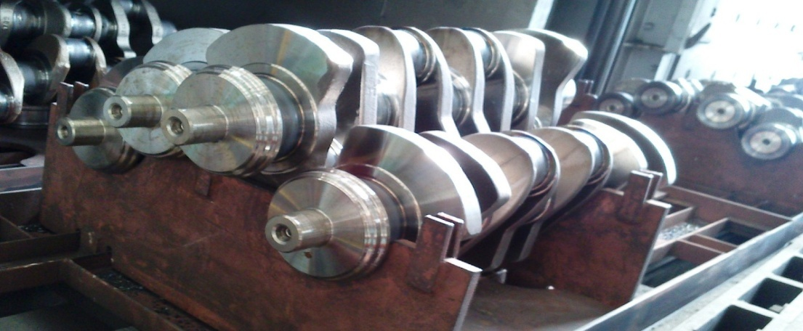

Green grinding

In this process the **journal J5** is grinded in grinding machine under the cutting feed of 0.01mm. The cycle time for this process is **220 seconds**.

Finish grinding of flange, face and pilot

MICROMATIC CNC GRINDER machine is used. Cycle time **330** **seconds**.

Finish grinding (Gear side and journal J1)

MICROMATIC CNC GRINDER machine is used. Cycle time **305 seconds.**

Finish grinding all pins & journals expect J1

CINETIC LANDIS grinding machine is used. The Cycle time is **675 seconds**.

End operations

After the grinding operation end operations are done on the both flange side and gear end side of the crankshaft. **BFW ORION H6600** is used for this operation. Two operation are processed in one time in this machine.

PCD OPERATION

Drilling, tapping, counter sinking, reaming FOD side. The cycle time of this process is **365** **seconds**.

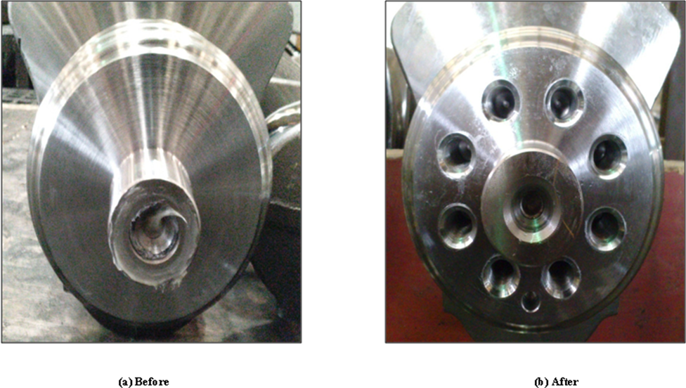

GEAR HAND SIDE MILLING

Keyway milling, remaining and slot milling is processed in this second operation of the end operation. The cycle time of this process is **425** **seconds**.

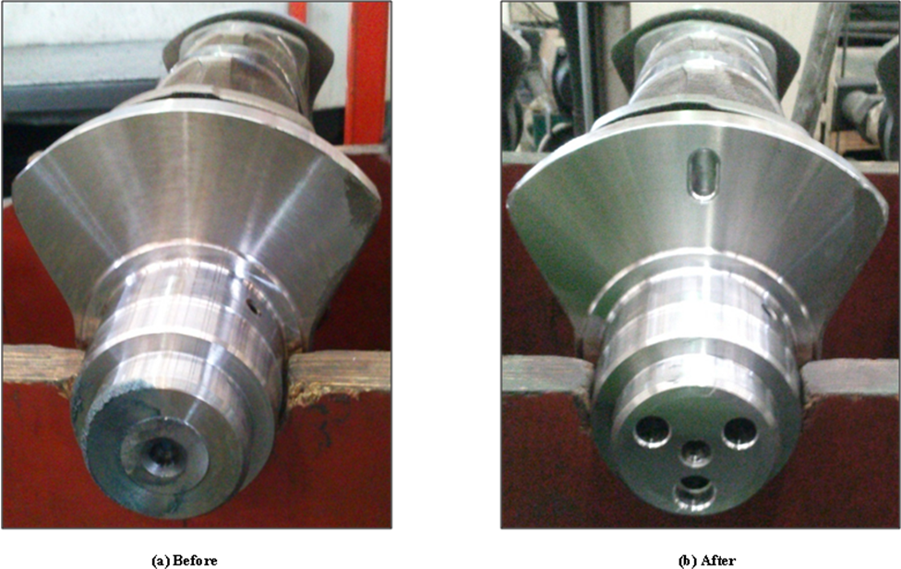

Dynamic Balancing

After end operations balancing operation is done to balance the crankshaft. This balancing operation is done cemb balancing machine and other balancing machines. The cycle time is **420 seconds.** The control panel of the balancing machine displays the amount of unbalanced mass on both sides of the crankshaft before and after the operation. If the amount of unbalance is under tolerances then the crankshaft will said to be dynamically balanced. Below the displays of the control panel before and after the balancing operation is shown

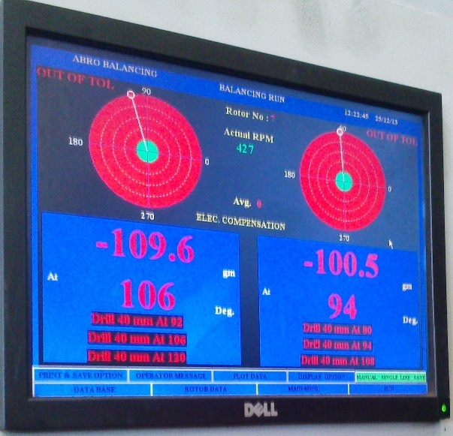 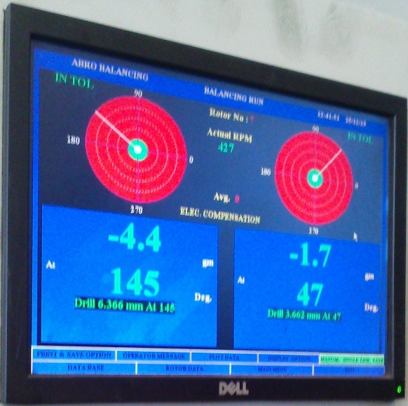

**unbalanced crankshaft balanced crankshaft**

Debarring

Just like debarring operation after milling operation was done, it is also done after dynamic balancing operation to remove sharp edges caused by the multiple drilling holes done during balancing process. The cycle time is **120 seconds**.

Magna flux

After deburring of the crankshaft it goes to magna machine which firstly magnetizes for crack detection and then demagnetizes it after detection. The cycle time of this inspection test is **120 seconds**.

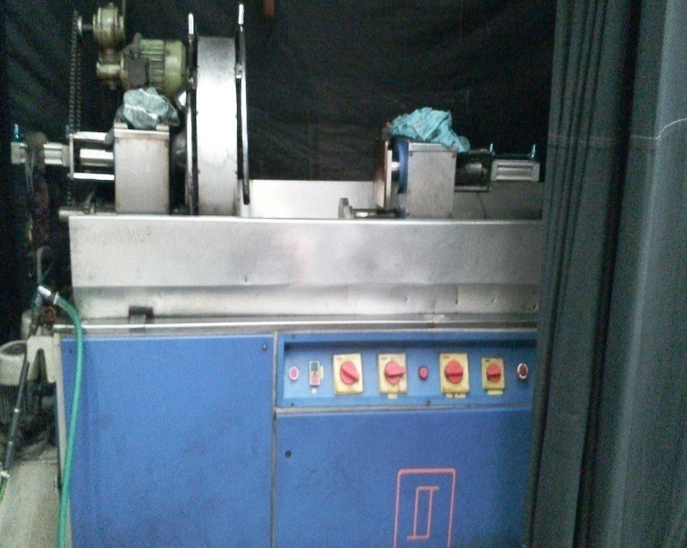

Tape polishing

After balancing the crankshafts go for the further surface finishing operations. Tape polishing is one of the modern surface finishing operations. This is done along with grinding process to give high surface finish to the crankshafts. The cycle time is **330 seconds.**

FINAL LAPPING

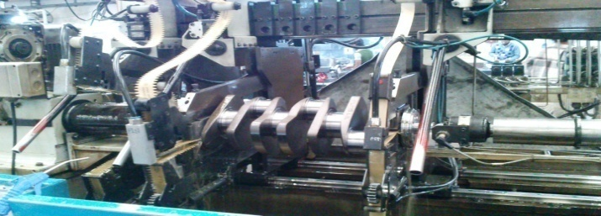 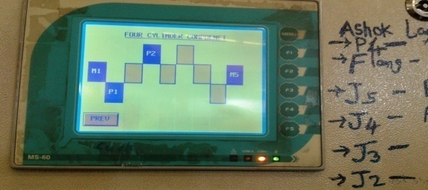

The cycle time of this process is **280 seconds**.

LAYOUT OF MACHINING PROCESS

|  |  |  |
| --- | --- | --- |
| (A)  FACING & CENTERING |  | ROUGH FINISH & TURNING (B) |

|  |
| --- |
| FINISH TURNING FLANGE DIA & FACE (C) |

|  |  |  |  |  |
| --- | --- | --- | --- | --- |
| INDUCTION HARDENING  (F) |  | OIL HOLE DRILLING & CHAMFERING (E) |  | ALL PIN ROUGH & FINISH MILLING (D) |

|  |  |  |  |  |
| --- | --- | --- | --- | --- |
| TEMPERING (G) |  | GREEN GRINDING JOURNAL J5 GRINDING (H) |  | FINISH GRINDING OF FLANGE, FACE & PILOT (I) |

|  |  |  |  |  |  |  |  |  |  |
| --- | --- | --- | --- | --- | --- | --- | --- | --- | --- |
| FINISH GRINDING (ALL PINS & JOURNALS EXPECT J1) (L) |  | | PCD ( COUNTER SINKING, REAMING FOD SIDE) (K) | | |  | | FINISH GRINDING GEAR SIDE AND JOURNAL J1 (J) | |
|  | |
| KEYWAY MILLING, REAMING & SLOT MILLING OF GEAR HAND SIDE (M) | | |  | | DYNAMIC BALANCING (N) | | |  | | DEBURRING (O) | |

|  |  |  |  |  |
| --- | --- | --- | --- | --- |
| FINAL INSPECTION & PACKING (R) |  | LAPPING & FINAL LAPPING (Q) |  | MAGNA FLUX (P) |

BAR GRAPH OF MACHINING CYCLE TIME

CYCLE TIME IN SECONDS

* **PROCESS L (ALL PIN FINISH GRINDING**) TAKES **675 SECONDS** WHICH IS HIGHER THEN OTHER PROCESSES.
* **PROCESS L IS THE BOTTLENECK** IN MACHINING LINE OF JCB 4.4L CRANKSHAFT.
* **PROCESS L TAKES 26.25 HOURS TO OBTAIN DESIRED OUTPUT WHICH IS 140**. THEREFORE WE **NEED TO INCREASE THE EFFICIENCY** OF THIS PROCESS.
* NEEDS TO DECREASE THE **CYCLE TIME OF PROCESS L ATLEAST 540 SECONDS**.
* NEED TO **DECREASE 135 SECONDS** FROM CURRENT CYCLE TIME OF PROCESS L.

|  |  |  |  |  |
| --- | --- | --- | --- | --- |
| **TASK** | **PROCESS** | | **CYCLE TIME** | **PRECEDENCE NO.** |
| A | FACING & CENTERING | | 540 SEC | 6876 |
| B | ROUGH FINISH & TURNING | | 508 SEC | 6336 |
| C | FINISH TURNING FLANGE DIA & FACE | | 467 SEC | 5828 |
| D | ALL PIN ROUGH & FINISH MILLING | | **615 SEC** | 5361 |
| E | OIL HOLE DRILLING & CHAMFERING | | 391 SEC | 4746 |
| F | INDUCTION HARDENING | | 585 | 4355 |
| G | TEMPERING | | 180 | 3770 |
| H | GREEN GRINDING JOURNAL J5 GRINDING | | 220 | 3590 |
| I | FINISH GRINDING OF FLANGE, FACE & PILOT | | 330 | 3370 |
| J | FINISH GRINDING GEAR SIDE AND JOURNAL J1 | | 305 | 3040 |
| K | PCD ( COUNTER SINKING, REAMING FOD SIDE) | | 365 | 2735 |
| L | FINISH GRINDING (ALL PINS & JOURNALS EXPECT J1) | | **675** | 2370 |
| M | KEYWAY MILLING, REAMING & SLOT MILLING OF GEAR HAND SIDE | | 425 | 1695 |
| N | DYNAMIC BALANCING | | 440 | 1270 |
| O | DEBURRING | | 120 | 830 |
| P | | MAGNA FLUX | 140 | 710 |
| Q | | LAPPING & FINAL LAPPING | 570 | 570 |
|  | | TOTAL WORK CONTENT**(TWC)** | **6876** |  |

**CALCULATION**

**Total available time in a day =** 21 hours**/**day (**75,600 sec**.)

**Required production in a day = 140 pieces/day**

**Desired Cycle time =** Production time per day **/** output per day

= 75,600/140

=  **540 SECONDS**

**Numbers of workstations = Total work content (TWC)/cycle time**

**= 6876/540**

= 12.773 = **13 approx**

**PRODUCTION LINE EFFICIENCY**

**Line efficiency = Total maximum time required for all operation * 100**

**Total no. workstation* Desired Cycle time**

**= 6876/13*540*100**

**Production Line efficiency = 97.94%**

**Balance delay = 1-Line Efficiency**

**= 1-0.97**

**= 0.3**

**Conclusion**

* **The objective is to group the work elements into station so that no station time exceeds 540 sec.**
* **If a line is perfectly balanced than the smoothness index will be zero.**
* **We need multiple line for production to achieve 140 pic per day**
* **CINETIC LANDIS grinding machine** is used for all pin finish milling. The Cycle time is **675 seconds which is higher in all process**. Needs advanced and improved machinery for this process.
* **The multitasking machine BFW ORION H6600 hold one operation when second is in process.**
* **The multitasking machine BFW ORION H6600 in which End operation & PCD operation is processed need to be replaced with single operation machine for PCD & End operation.**